CHRIST University
Department of Computer Science
M.Sc. in Artificial Intelligence & Machine Learning (MSAIML)
Data Structures — Practical / Lab Assessment
Reg No: 2648555

Scenario
GenoScan AI is a bioinformatics start-up building a machine-learning model that predicts gene-regulation activity from DNA sequences. Before the data is fed to the model, a feature-extraction module must locate every occurrence of short, biologically important patterns called motifs (for example, the binding site GCTAG) inside long DNA reads made up only of the characters A, C, G and T. The number and positions of these motifs become input features for the ML model.
The current prototype uses a brute-force search, which becomes very slow when millions of reads are processed. Repetitive regions such as AAAAAAAA…, which are common in real genomes, make it even worse. You have been hired as a data-structures engineer to replace this module with an efficient, verifiable string-matching component and to justify your choice with evidence.

Part A — Core Implementation:
- LPS Array Construct:
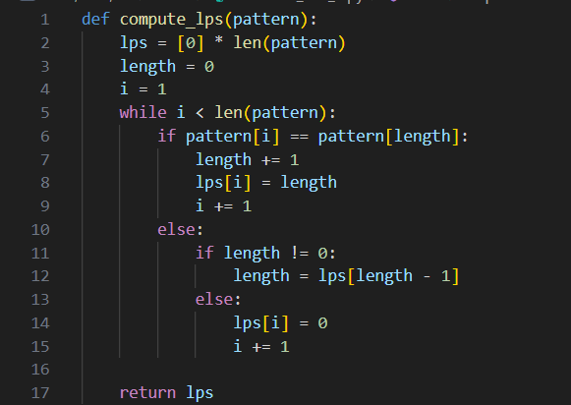

- Naïve (Brute-Force) Matching:
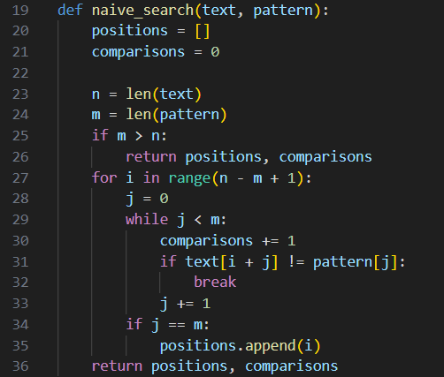

- Knuth–Morris–Pratt (KMP) Matching:
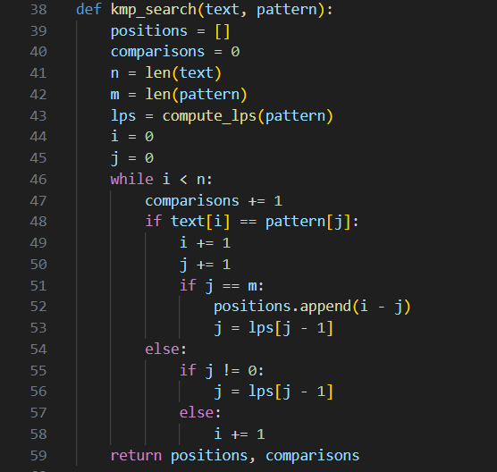

- Rabin – Karp Method:
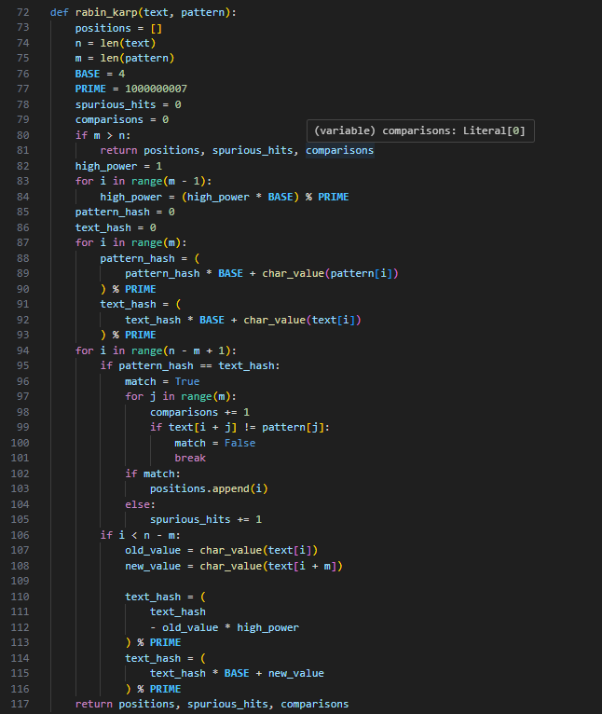

- Edge-case handling:
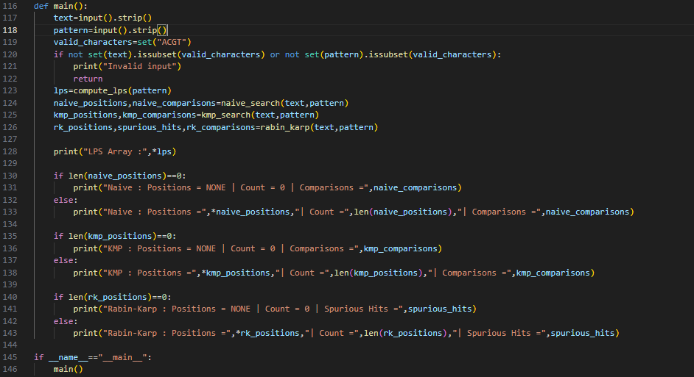

Part B — Inputs & Outputs:



